**NAME OF THE QUESTION**

Creating Microservices for account and loan

**CODE**

***Account Microservice:***

package com.cognizant.account;

import org.springframework.web.bind.annotation.*;

@RestController

@RequestMapping("/accounts")

public class AccountController {

@GetMapping("/{number}")

public Account getAccountDetails(@PathVariable String number) {

return new Account(number, "savings", 234343);

}

record Account(String number, String type, double balance) {}

}

**OUTPUT**

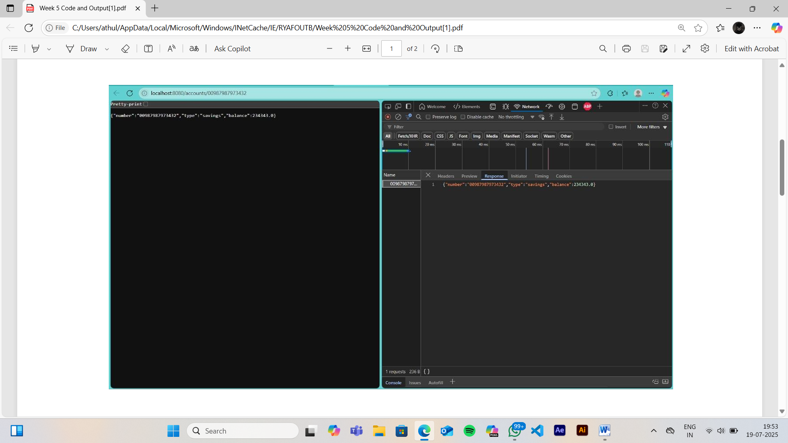

***Loan Services:***

**LoanController.java:**

package com.cognizant.loan;

import org.springframework.web.bind.annotation.*;

@RestController

@RequestMapping("/loans")

public class LoanController {

@GetMapping("/{number}")

public Loan getLoanDetails(@PathVariable String number) {

return new Loan(number, "car", 400000, 3258, 18);

}

record Loan(String number, String type, double loan, int emi, int tenure) {}

}

Server.port:8081

**OUTPUT**

